User first attaches the newest USysAllSpecs table using VPro function.
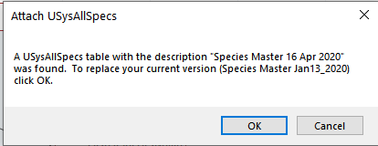

VPro finds old codes and makes a list of changes to make
